|  |  |  |  |  |  |
| --- | --- | --- | --- | --- | --- |
| Date | 8-Dec-22 | | | Tester Name | Shahabuddin Syed |
| Environment | Penfax - Test | | | Login used |  |
| Operating System | Windows | Version: | Update: | | |
| Software Used | Edge | Version: | Update: | | |
| Select Software | Version: | Update: | | |
| Release version | 22.4.1 | | | | |
| Title | V5- 5.04 | | | | |
| Test Type | Regression | | | | |
| Test Scenario | Weekly Annuity Rate | | | | |
|  |  | | | | |
| Expected Results |  | | | | |
| Pass/Fail | Pass | | | JIRA# | N/A |

Describe your steps with screenshots:

Need to find rates

Go to the URL: <https://www.bankofcanada.ca/rates/interest-rates/lookup-bond-yields/?page_moved=1>

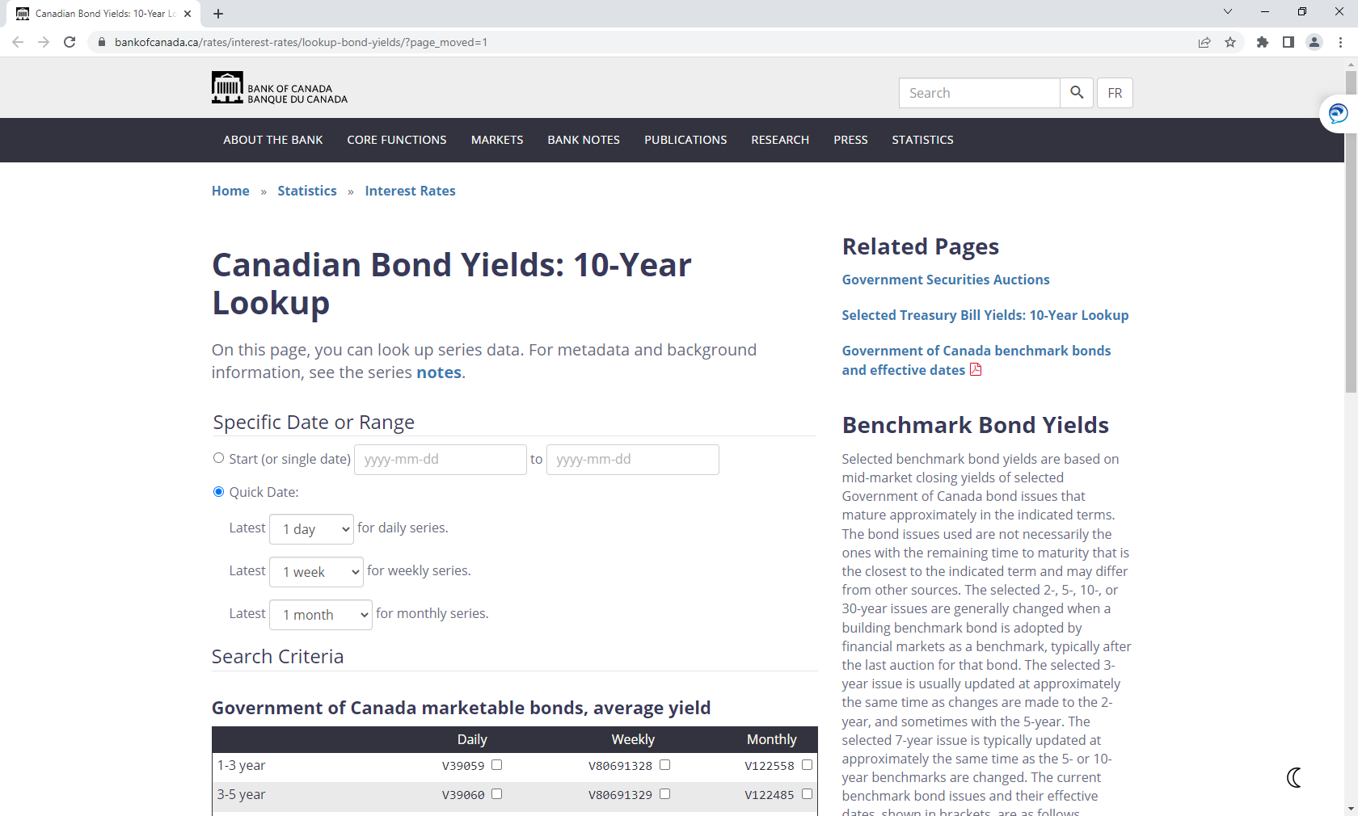

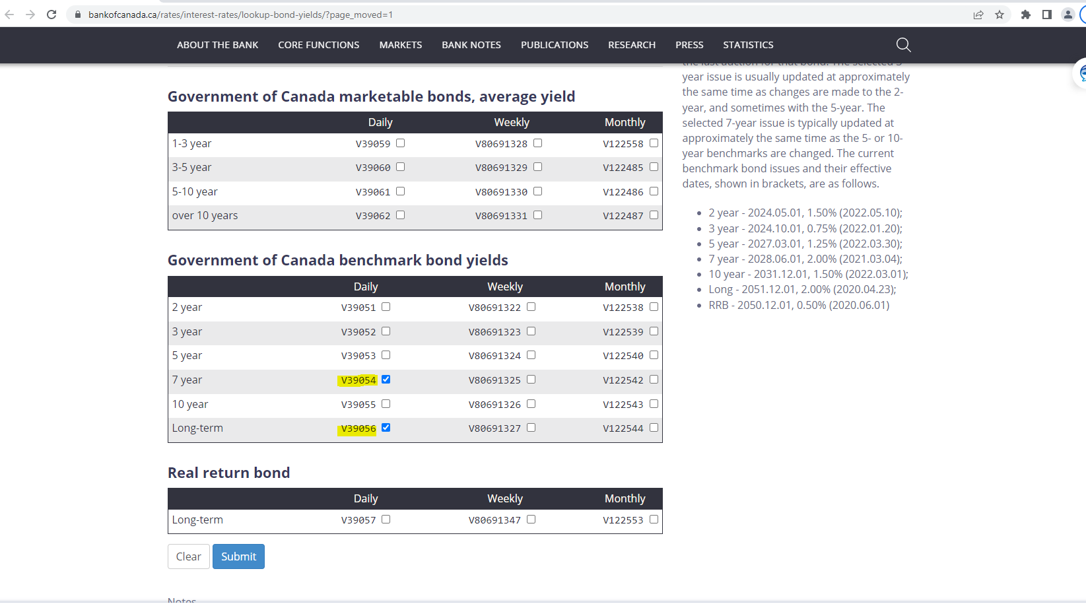

Click on Submit

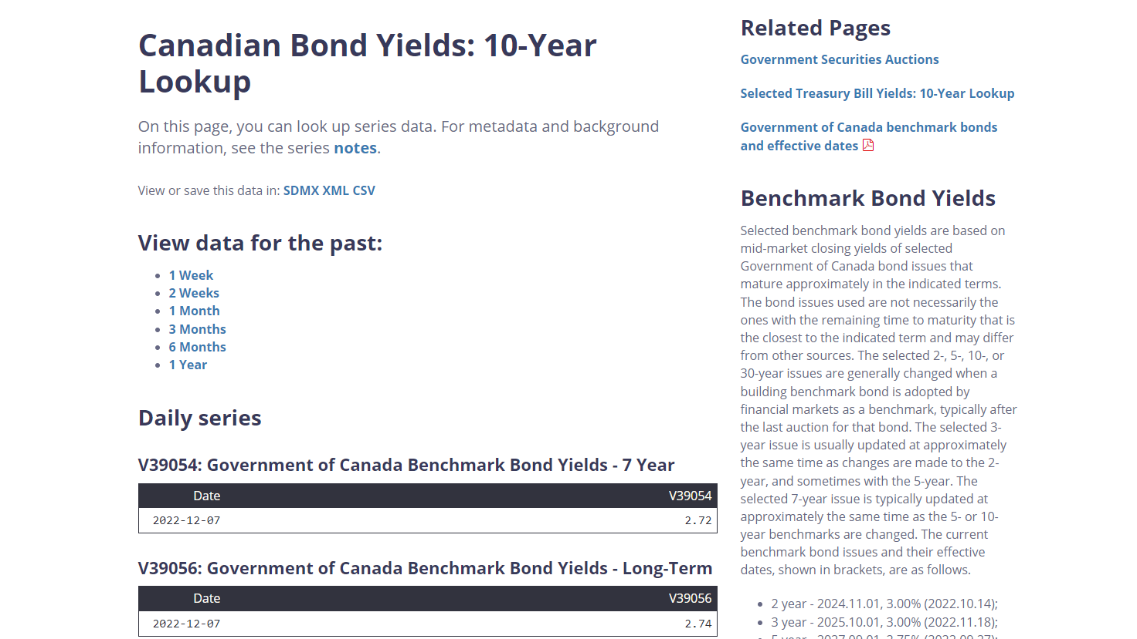

Save the file to csv format

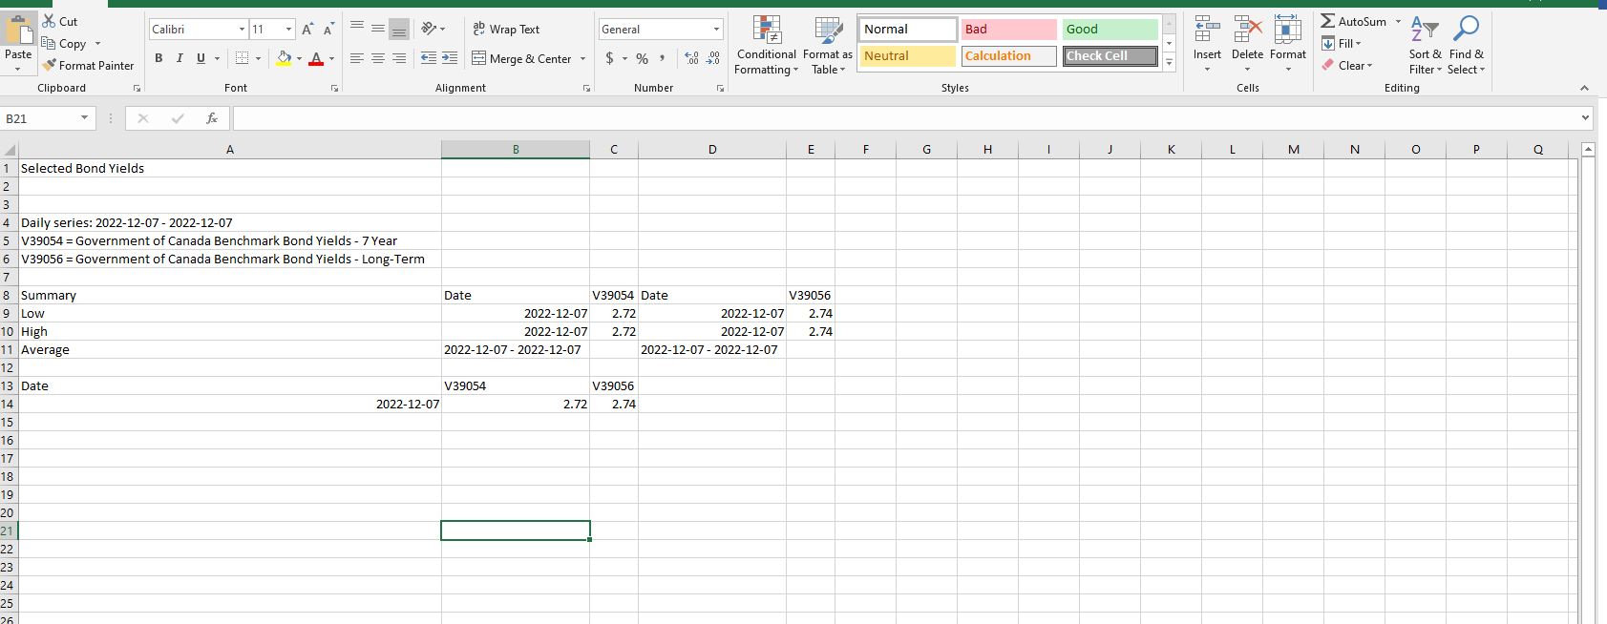

Open H Drive go to

Pension Programs/PEPP/Templates and Forms/Retirement

In the Retirement folder, find “Annuity Rate Change”.

Enter the date and rates for the V39054 and V39056. The rest will calculate on their own

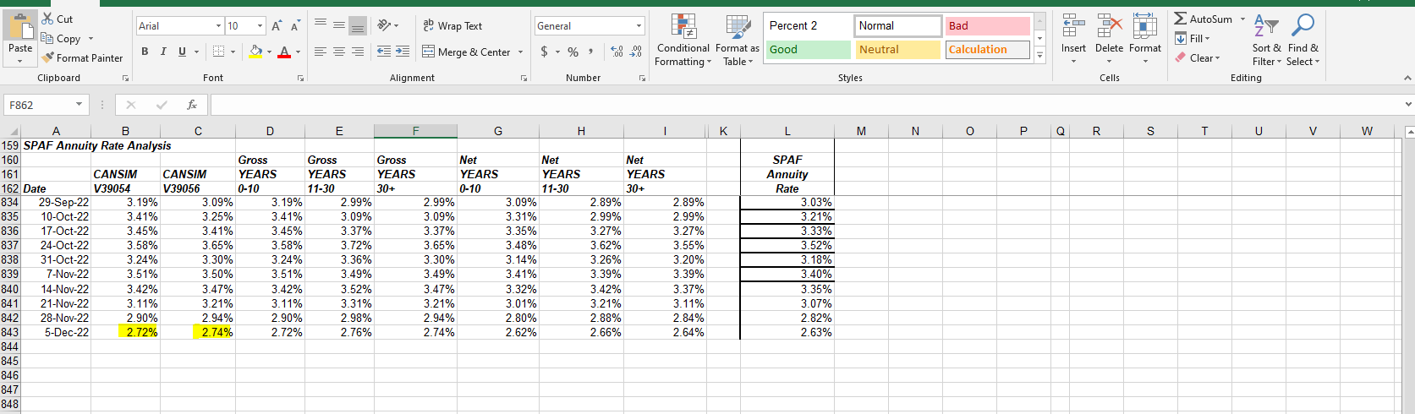

Arrange the order of the printed pages as follows and paper clip them together:

* + Annuity Rate PENFAX Table Update Form (TOP.)
  + Rate Page from the Internet.
  + Annuity Rate Change Table (BOTTOM).

1. Once QA has entered the interest rates in PENFAX, a copy will be provided to the PEPP *Supervisor* to audit on PENFAX and sign off on “Annuity Rate PENFAX Table Update Form”.

The annuity rates in PENFAX are found under, **Plan Rules**, **Interest**

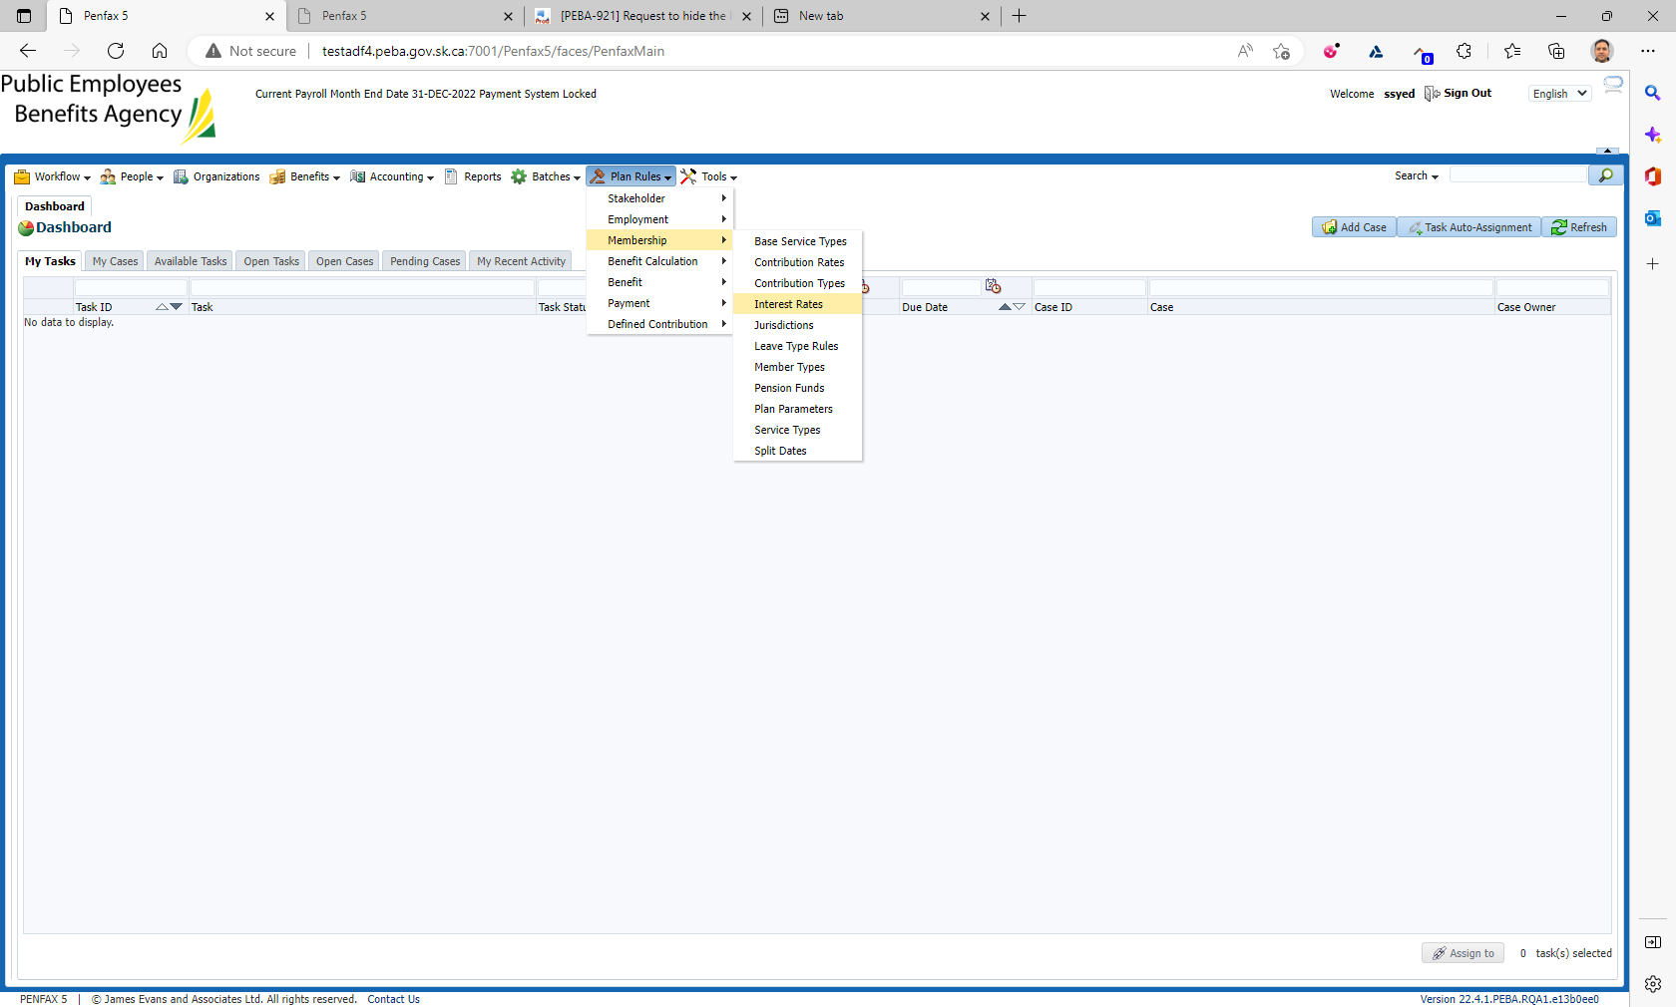

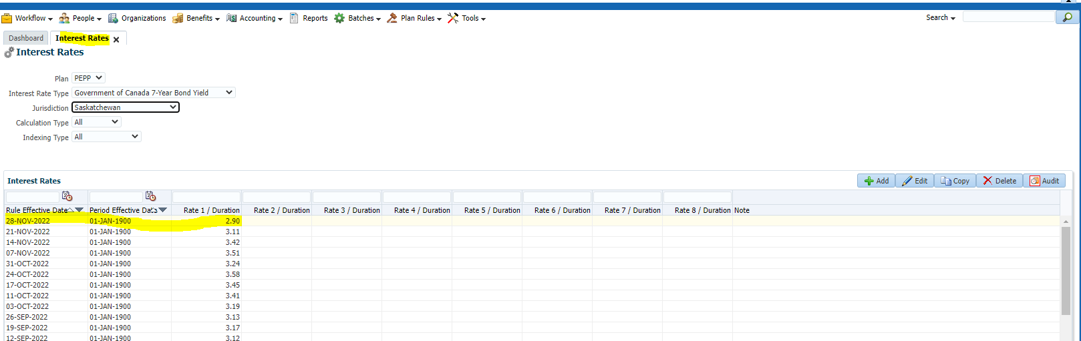

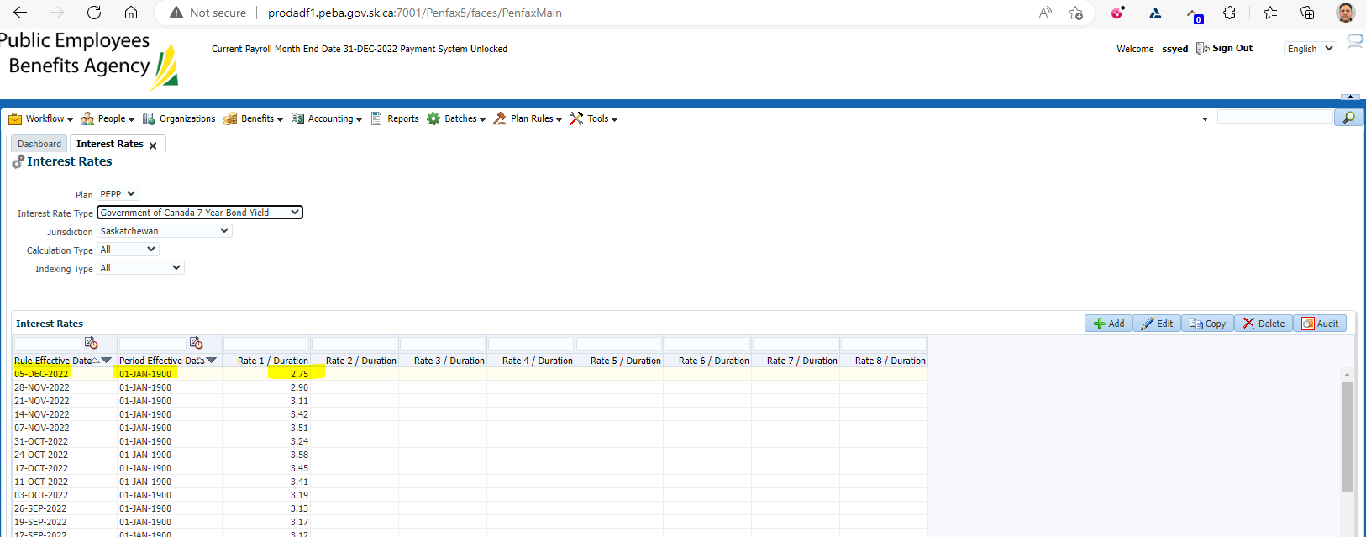

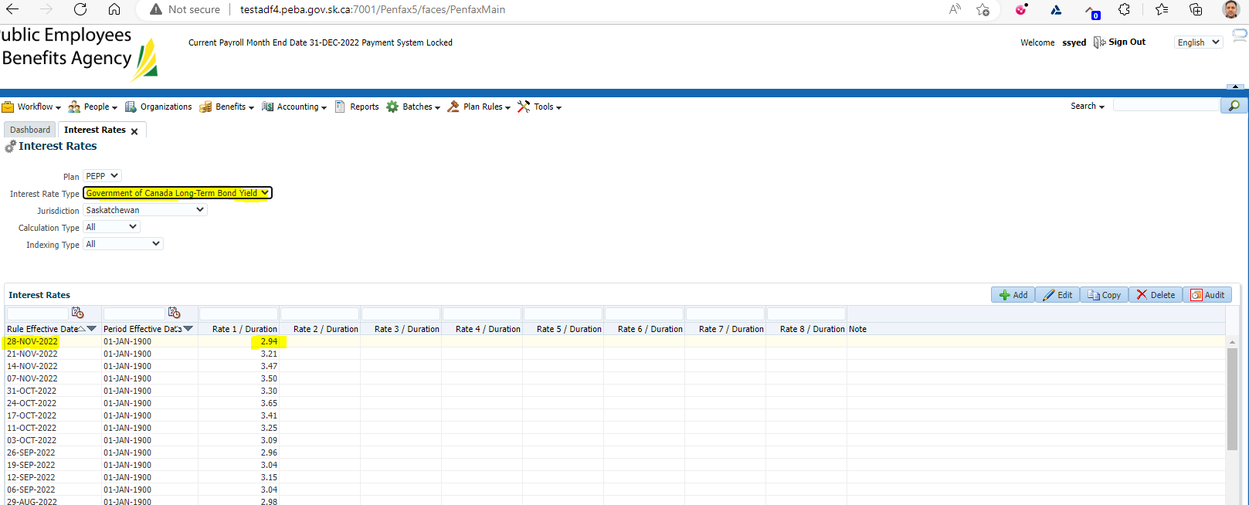

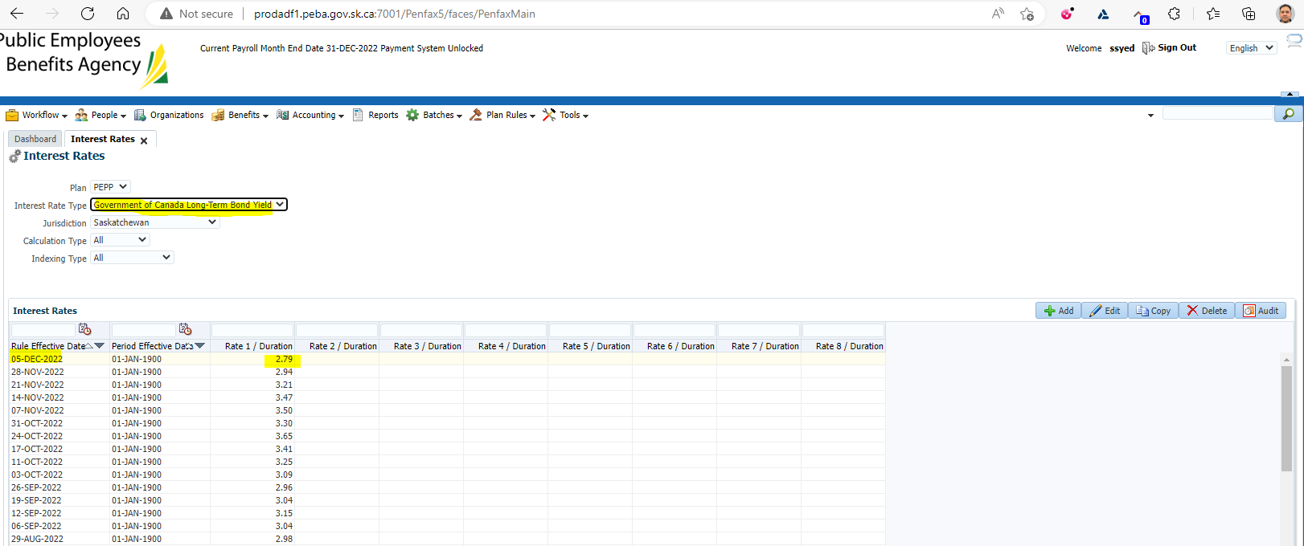

Current rates as of Dec 5

V39054 – 2.72% ; V39056 – 2.74%